The Stock Market is a long term bet

Prashant Raghuwanshi

DSC, Bellevue University

[DSC500-T301 Introduction to Data Science (2215-1)](https://cyberactive.bellevue.edu/webapps/blackboard/execute/courseMain?course_id=_500210_1)

Professor [Catherine](mailto:Catherine.williams@bellevue.edu) Williams

03/28/2021

**ABSTRACT:**

This article aims to evaluate the use of techniques like Google trend Analysis, Google searches, and open-source historical stock movement graphs in conjunction with the management model CRISP-DM. It helps us figure out "The Stock Market is a long term bet" for the retail investor is a widespread myth, or it is a fact.

The study assumes that a retail investor had $1000 a decade ago and wants to invest in the best Stock for the long term during that period and decided to cash out his investment after a decade.

The Stock Market is a long term bet

1. **INTRODUCTION**

When any new IPO is launched in the Stock market, most analysts say this Stock has a promising future for long-term investors. Most of them would start comparing some successful stocks history and concluding that you will be a millionaire now if you invested $1000 in this Stock a decade back and will figure that the stock market is a long-term bet.

However, It is almost difficult to predict the future of any stock. No one has a guaranty when the real brain behind the organization's growth would step out or pick up an incorrect plan in a decade. Here I will compare the growth path of Tesla vs. the best recommended investing auto stock during Tesla IPO time. Along with this, I want to show the odd of a retail investor to invest $1000 in Tesla IPO.

I am using the Visualization Statistic study method. I will discuss it in the sections below and implemented it within a data mining management model called CRISP-DM.

This paper is organized as follows. Section 2 presents a review of CRISP-DM described. Finally, we conclude our work in section 3.

1. **CRISP-DM**

The Cross-Industry Standard Process for Data-Mining – CRISP-DM is a model of a data mining process used to solve problems by experts. The model identifies the different stages in implementing a data mining project, as described bellow

The model proposes the following steps:

* Business Understanding – to understand the rules and business objectives of the company.
* Understanding Data – to collect and describe data.
* Data Preparation – to prepare data for import into the software.
* Modeling – to select the modeling technique to be used.
* Evaluation – Evaluate the process to see if the technique solves modeling and creating rules.
* Deployment – to deploy the system and train its users.

**2.1 Business Understanding**

The first phase of the CRISP-DM is the Business Understanding. For this paper's sake, this phase is aimed at defining the business objectives of our research. The proposed goal is to detect whether the long-term stock investment works for every retail investor and does most of the long-term investors catch the right bus for their successful long-term investment journey.

It is initial high-level research. I am pulling out all primary research data from google search, google trend analysis, and stock price history graph to figure out the answers for the below questions.

1. What was the IPO list price of Tesla during the IPO listing?
2. The best Auto stock present in the market at the same period.
3. Advisors review comments
4. What are the other parameters or trends on which retail investors and advisors think before putting money in any stock for the long term?

* Stick to millionaire investing rule (Warren Buffet advice)
* Trending Stock during that period
* Consistent stock performance chart
* Company product sales near your surrounding
* Future of New technology as compared to the present booming technologies
* TESLA STOCK Vs. Casino trend comparison
* Keyword "Investment" related question searches

1. 2021- Stock price graph (Decade long-term investment conclusion).
   1. **Data Understanding & Data Preparation**

Please refer to the collected raw data visualization from google trend and google search related to the business understanding sections' questions.

1. What was the IPO list price of Tesla during the IPO listing?

* **Data Collected from google search**:

Tesla IPO details: Tesla went public ten years ago today, pricing shares at $17

The company raised around $226 million in its IPO.

1. One of the best trending Auto stock present in the market during the same period (Randomly picked up FORD stock).

* Comparison of trend searches on stock price (showing how heavily retail investors are invested in auto stock)

Comparison of sentiments on stock price:

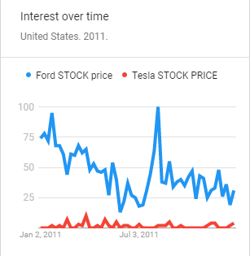

1. Advisors review comments on tesla stock (2011)

* Tesla recommendations from an analyst:
* <https://www.fool.com/investing/general/2011/12/13/why-im-not-buying-tesla-motors.aspx>

1. Other Parameters data :
2. Stick to millionaire investing rule (warren buffet advice)

* Trend search shows the interrelation between Warren Buffet search with Ford Stock search and tesla stock search during 2011.

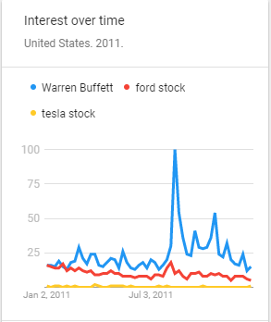

1. Consistent stock performance chart : (Stock history)

* Screenprint showing Ford compatible price growth chart during 2009-2011 (from google search)

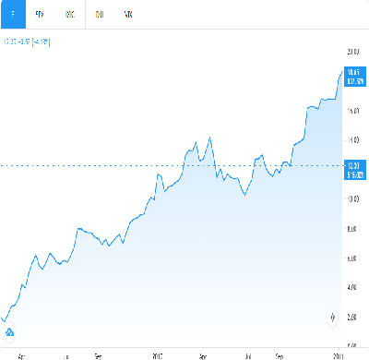

1. Company product sales near your surrounding

* Comparison of trends searches for Ford focus & Tesla Modle3 @ 2011
  + 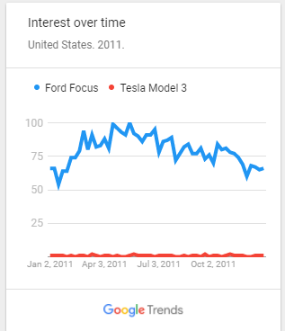

1. Future of New technology as compared to the present booming technologies

* Comparison of trends search for future of gar car and electric car
* 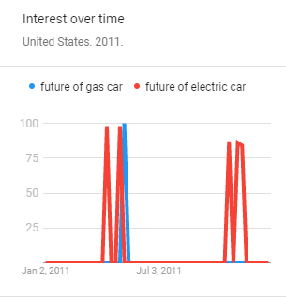

1. Investment question keyword search comparison

* Comparison of trend search invest in Tesla vs. invest in ford

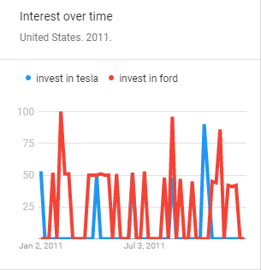

1. TESLA STOCK Vs. Casino trend comparison

* Trend search shows the comparison between tesla stock and plays in the casino

(surprisingly few spikes in tesla investment is near with casino search trends)

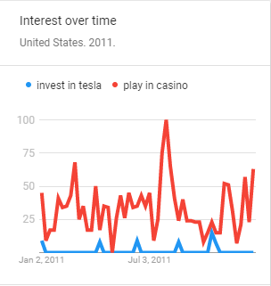

1. Decade stock price graph (long-term history).

* Recent price graph showing decade long performance of stocks

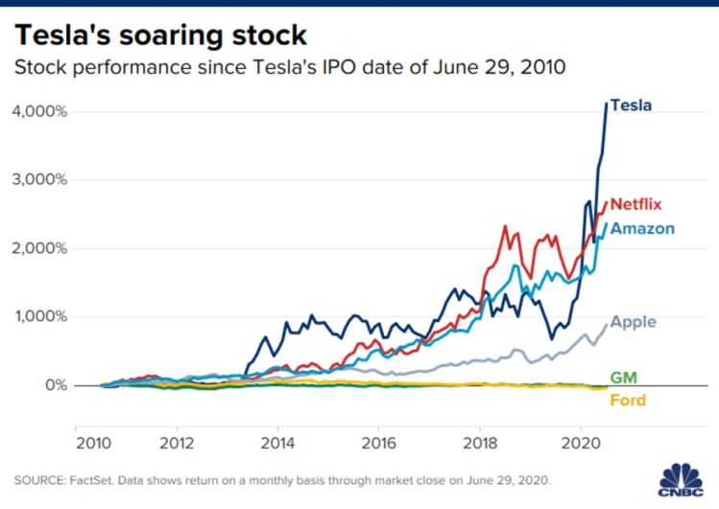.

* Decade long Auto index price

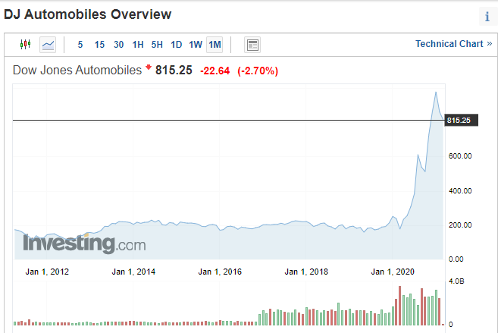

* 1. **Modeling ,Evaluation & Decison :**

This phase uses modeling techniques on data prepared in the Data Preparation phase

I have limited information on modeling techniques in my case study, so I use the layman manual trends graph comparison technique to evaluate my findings.

|  |  |  |  |  |  |
| --- | --- | --- | --- | --- | --- |
| Parameters to buy Stock for long term | Keyword | Avg FORD Score | Avg TESLA Score | evaluation Findings | Decision |
| STOCK HOLDING Trend during 2011 | STOCK PRICE | 70 points | 5 points | Retails investors had invested more in FORD stock | 60 % probability of going with FORD STOCK for Decade investment |
| Advisors review comments(google search) | TESLA recommendation 2021 | Positive | Negative | Retail investors are avoiding Tesla for long term bet | 95% probability of going with FORD STOCK for Decade investment |
| Stick to millionaire investing rule | Warren Buffet, FORD STOCK, Tesla Stock | 15 Points | 2 Points | Found interrelation between Warren Buffet search with Ford Stock search during 2011-Shows more retail investors are following advice and glued with ford stock | 86% probability of going with FORD STOCK for Decade investment |
| Consistent stock performance chart (google search) | FORD stock price (2009-2011) | Positive | NA | found consistent ford stock price performance 2009-2011 | 95 % probability of going with FORD STOCK for Decade investment |
| Company product sales near your surrounding | FORD FOCUS, TESLA MODEL 3 | 75 | 2 | Peoples showing more interest in FORD cars | 96% probability of going with FORD STOCK for Decade investment |
| Want to play in the casino | INVEST in TESLA, CASINO | NA | 5 | surprisingly few spikes in tesla investment search points are matching with some of the spikes in casino search -might be some investors are considering Tesla as a casino bet | 95% Investing in Tesla due to casino effect |
| Comparison of trend search invest in Tesla vs. invest in ford | invest in Tesla, invest in ford | 75 | 25 | It's a good indication that retails investors started asking tesla future investment questions | 66 % probability of going with FORD STOCK for Decade investment |
| Future of New technology as compared to the present booming technologies | Gas engine, Electric Car | 25 | 75 | a good indication that retail started searching on electric car | 95 % probability of going with Tesla STOCK for Decade investment |
| Decade Long Stock Price Performance (google search) | TESLA & FORD STOCK PRICE | $12 | $900 | After 2011 ford stock price started dropping consistently, however TESLA stock started performing | 90 % of retails investors would lose money for their decade long trade |

|  |  |  |  |
| --- | --- | --- | --- |
| STOCK NAME | 2011 | 2021 | % Returns |
| TESLA STOCK | 17 | 900 | 5194.117647 |
| FORD STOCK | 11 | 12 | 9.090909091 |
| DOW AUTO INDEX | 200 | 800 | 300 |

**3) Conclusion & Deployment:**

After studying all the parameters mentioned above, statistics and

evaluating the final returns.

* It shows an average young retail individual Stock investor @ 2011 would prefer to invest their $1000 in FORD stock for a decade. However, very tiny retail investors might be invested $1000 in Tesla instead of casinos in 2011 and got a good return.
* Instead of investing $1000 in individual stocks, if retail investors invested that money in index funds, they will ripe up the long-term investment benefits.

**Myth – Stock Market is for Long term Investments**

**Truth – Except for few lucky retail investors, It's not true for most retail stock investors. However, it looks true with moderate gain for long-term index fund investors but retails investors are not actively considering those funds.**

**References**

Seth Stephens (2017). *Everybody Lies*. DEY ST.

Web references:

<https://www.fool.com/investing/general/2011/12/13/why-im-not-buying-tesla-motors.aspx>

<https://www.investing.com/indices/dj-automobiles>

<https://trends.google.com/trends/yis/2011/US/>